3GPP TSG RAN WG1 Meeting #125 R1-2603708
Dalian, China, May 18th – 22nd, 2026
Agenda Item: 10.8.2
Source: EURECOM
Title: Aspects of integration with communication
Document for: Discussion and decision

Introduction
According to Releases 19 and 20 ISAC, the use cases, channel model and evaluation assumptions are defined as follows:
- Five use cases are studied for ISAC:
- UAVs
- Humans indoors and outdoors
- Automotive vehicles
- Automated guided vehicles (e.g. in indoor factories)
- Objects creating hazards on roads/railways, with a minimum size dependent on frequency
- Six sensing modes: transmission reception point (TRP)-TRP bistatic, TRP monostatic, TRP-user equipment (UE) bistatic, UE-TRP bistatic, UE-UE bistatic, UE monostatic are supported in these use cases.
- ISAC channel model is specified in Section 7.9 in TR 38.901.
- Evaluation assumptions and performance metrics are specified in TR 38.765.
A unified design for sensing and communication is required for ISAC use cases.
The following agreements are noted in RAN1#124b:
Agreement:
On RS for ISAC, study at least the following aspects, considering sensing performance, resource overhead and impact to communication
- RS for communication is reused for sensing
- Enhanced RS for sensing, taking reuse of RS for communication as starting point
  - Note: Part of or all of the RS may be used for communication purpose, and it does not mean the final decision on whether the enhanced RS is used for communication purpose is to be made in this agenda.
- Dedicated RS for sensing

Agreement:
Study RE patterns of RS for sensing, considering sensing performance, resource overhead and impact to communication.
- Note: enhancements on RS sequence if any will be discussed in agenda 10.8.3.

Agreement:
On measurement for ISAC, study at least the following aspects.
- Measurement definitions/levels for TRP-side measurement, taking the measurement Levels studied in NR ISAC as starting point
- Measurement definitions/levels for UE-side measurement
- Impacts of non-ideal factors on measurement
- Other aspects are not precluded
- Note: this discussion may or may not mean there is specification impact

Agreement:
On measurement report for ISAC, study at least the following aspects and applicable scenarios (e.g., sensing modes, targets, etc.) from RAN1 perspective.
- Measurement reporting mechanism from UE
  - Option 1A: The UE measurements and/or assistance information if needed from UE can be directly sent to aNB
  - Option 1B: The UE measurements and/or assistance information if needed from UE can be sent to SF
- Measurement reporting mechanism from aNB
  - Option 2A: The aNB measurements and/or assistance information if needed from aNB can be directly sent to UE
  - Option 2B: The aNB measurements and/or assistance information if needed from aNB can be sent to SF
- The study may require cross-WG coordination.
- Note: combination of multiple options is not precluded.
- Note: measurements in each option may be different

Agreement:
On measurement report for ISAC, study impacts from at least the following aspects from RAN1 perspective
- Measurement reporting mechanism
  - E.g., Periodic, semi-persistent, aperiodic, event-triggered report as starting point
  - Reporting signaling e.g., L1, L2, higher layer, etc.
- Other aspects are not precluded
- The study may require cross-WG coordination.

Discussion

Slot design for sensing and communication
A unified design of sensing and communication requires a new slot design. Time and frequency resources must be allocated to sensing and communication functions to guarantee sensing and communication performance. In some ISAC use cases, the distances among the transmitter, the target and the receiver are small under 100m like human indoor and outdoor sensing and automated guided vehicle in factory. These applications need to fast switch between sensing and communication to achieve the communication and sensing requirements.

DL slots for ISAC
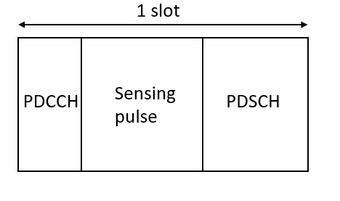
- Continuous PDSCH resource
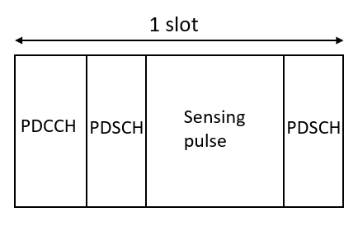
- Discontinuous PDSCH resource
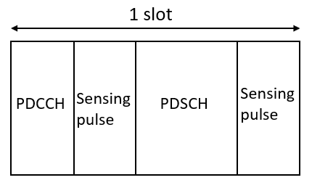
- Discontinuous sensing resource
Figure 1: Slot structure for sensing and communication signals in DL
In Figure 1, the DL slot structure for integrated sensing and communication is introduced. This slot structure is used for DL communication and supports the following sensing modes: TRP-TRP bistatic, TRP monostatic, TRP-UE bistatic.
In Figure 1, physical downlink control channel (PDCCH) is transmitted by the base station (BS/aNB) at the beginning of a slot to indicate the time and frequency resources of physical downlink shared channel (PDSCH). Communication data is encoded and transmitted via PDSCH. The resource for sensing signal is configured in the middle of a slot.
In Figure 1a, sensing resource is configured after PDCCH and before PDSCH. In Figure 1b, sensing resource is configured in the middle of two PDSCH resources in a slot. In Figure 1c, PDCCH resource is configured in the middle of two sensing resources in a slot. The aNB can preconfigure the time and frequency resources in a slot for sensing signal then inform the receiver allowing it to detect the sensing signal in those resources. The aNB sends downlink control information (DCI) contained in PDCCH or radio resource control (RRC) signaling to the UE in order to indicate time and frequency resources of sensing signal. PDCCH used to indicate sensing resource can be transmitted in the same or different CORSET as PDCCH used to indicate communication resource.
Proposal 1: In a DL slot, communication and sensing resources are configured in time division multiplex.
Proposal 2: In a DL slot, sensing resource can be configured before, after PDSCH resource or in the middle of two PDSCH resources.
Proposal 3: PDCCH used to indicate sensing resource can be transmitted in the same or different CORSET as PDCCH used to indicate communication resource.

UL slots for ISAC
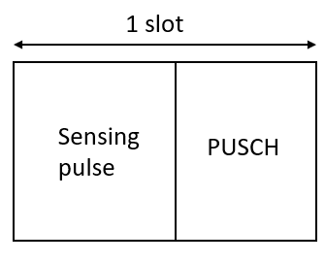
- Continuous PUSCH resource
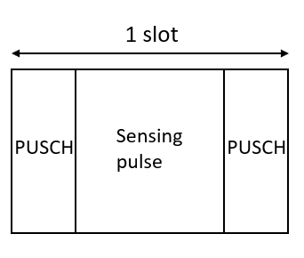
- Discontinuous PUSCH resource
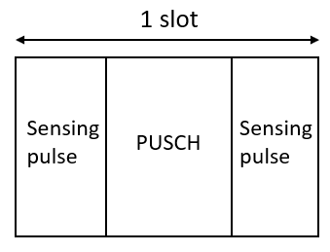
- Discontinuous sensing resource
Figure 2: Slot structure for sensing and communication signals in UL
In Figure 2, the UL slot structure for integrated sensing and communication is introduced. This slot structure is used for UL communication and supports the following sensing modes: UE-TRP bistatic.
In Figure 2, communication data is transmitted by the UE to the aNB via physical uplink shared channel (PUSCH). Sensing resource is multiplexed with communication resource in time division multiplex (TDM) in a slot as shown in Figure 2. Sensing resource is configured before (in Figure 2a) or after PUSCH. In Figure 2b, sensing resource is configured in the middle of PUSCH. In Figure 2c, PUSCH is configured in the middle of sensing resources.
In one mode, sensing resources are preconfigured to the UE by the aNB through DCI or RRC signaling. The period of sensing resources is indicated by DCI or RRC signaling. In another mode, the UE requests the aNB to configure sensing resource through uplink control information (UCI) when it needs to carry out a sensing task then the aNB configures sensing resource through DCI.
PDCCH used to indicate sensing resource can be transmitted in the same or different CORSET as PDCCH used to indicate communication resource.
Proposal 4: In an UL slot, communication and sensing resources are configured in time division multiplex.
Proposal 5: In an UL slot, sensing resource can be configured before, after PUSCH resource or in the middle of two PUSCH resources.
Proposal 6: In one mode, sensing resources are preconfigured to the UE by the aNB through DCI or RRC signaling. The period of the sensing resources is indicated by DCI or RRC signaling.
Proposal 7: In another mode, the UE requests the aNB to configure sensing resource through UCI when it needs to carry out sensing task then the aNB configures sensing resource through DCI.

Sensing reference signal design
The communication signal is agreed to be studied as an option for the use of the sensing signal. For the case where the aNB transmits the sensing signal such as TRP monostatic, TRP-UE bistatic, TRP-TRP bistatic, CSI-RS is studied as a starting point for sensing RS. TRS is a special case of CSI that will be studied together with CSI-RS. For the case where the UE transmits toward the aNB as UE-TRP bistatic, SRS is studied as a starting point for sensing RS.
A dedicated sensing RS is also agreed as another option. In this case, for TRP monostatic, TRP-UE bistatic, TRP-TRP bistatic, DL-PRS is studied as a starting point.
Proposal 8: For the case where the aNB transmits the sensing signal such as TRP monostatic, TRP-UE bistatic, TRP-TRP bistatic, CSI-RS is studied as a starting point for sensing RS.
Proposal 9: TRS is considered in the study of CSI-RS.
Proposal 10: For the case where the UE transmits toward the aNB as UE-TRP bistatic, SRS is studied as a starting point for sensing RS.
Proposal 11: DL-PRS is studied as a starting point for a dedicated sensing RS in TRP monostatic, TRP-UE bistatic, TRP-TRP bistatic.

Conclusion
Proposal 1: In a DL slot, communication and sensing resources are configured in time division multiplex.
Proposal 2: In a DL slot, sensing resource can be configured before, after PDSCH resource or in the middle of two PDSCH resources.
Proposal 3: PDCCH used to indicate sensing resource can be transmitted in the same or different CORSET as PDCCH used to indicate communication resource.
Proposal 4: In an UL slot, communication and sensing resources are configured in time division multiplex.
Proposal 5: In an UL slot, sensing resource can be configured before, after PUSCH resource or in the middle of two PUSCH resources.
Proposal 6: In one mode, sensing resources are preconfigured to the UE by the aNB through DCI or RRC signaling. The period of the sensing resources is indicated by DCI or RRC signaling.
Proposal 7: In another mode, the UE requests the aNB to configure sensing resource through UCI when it needs to carry out sensing task then the aNB configures sensing resource through DCI.
Proposal 8: For the case where the aNB transmits the sensing signal such as TRP monostatic, TRP-UE bistatic, TRP-TRP bistatic, CSI-RS is studied as a starting point for sensing RS.
Proposal 9: TRS is considered in the study of CSI-RS.
Proposal 10: For the case where the UE transmits toward the aNB as UE-TRP bistatic, SRS is studied as a starting point for sensing RS.
Proposal 11: DL-PRS is studied as a starting point for a dedicated sensing RS in TRP monostatic, TRP-UE bistatic, TRP-TRP bistatic.

